**Leadership Toolkit for General Practice Nurses- Midlands Region**



**Foreword**

The role of the nurse in general practice has evolved massively over the last 30 years. Once seen as a less dynamic nursing career choice the role of the general practice nurse (GPN) is unrecognisable from its mid-century roots, following the instructions of the general practitioner (GP).

GPNs are now the first point of contact for many patients with complex and specialist needs who are managing chronic long-term conditions from diagnosis, ongoing treatment, and care.

GPNs are the backbone of a care system designed, where possible, to enable patients to be cared for in the community and avoid hospitalisation.

Development of the GPN role has enabled this progression and there is a commitment to continue this development further, to ensure that the contribution of GPNs continues to have a positive impact on population health, using evidence-based practice and working in collaboration with other healthcare professionals.

This toolkit has been co-produced with GPNs themselves and provides a one stop shop of development resources designed to support GPNs to not only achieve their full potential but also develop their leadership style and skills to help futureproof this integral healthcare role.



Carol Love-Mecrow

Deputy Director of Clinical Leadership and Education, Nursing Midwifery and AHP

Workforce Training and Education Directorate NHS England Midlands

**Contents**

Introduction 4

Toolkit Explained 5

Current Evidence 6

Area 1: Compassionate Leadership 8

Area 2: Difficult Conversations 10

Area 3: Conducting Appraisal’s 12

Area 4: Quality Improvement 15

Area 5: Preparing for a CQC inspection as a lead nurse 17

Area 6: Leading the next generation of the Nursing workforce 19

Area 7: Professional Nurse Advocate 21

Area 8: Preceptorship 23

Area 9: Wellbeing 26

Area 10: Recruitment 27

Area 11: Leading Meetings 28

References 29

|  |
| --- |
| Introduction General practice nurses are an integral part of the primary care workforce, in November 2023 19.2% of all appointments in General practice were led by a general practice nurse (NHS Digital, 2024).  Emphasis is normally put into training and developing clinical skills to ensure patient’s needs can be met, but a general practice nurse’s position is much more than just a clinical one. General practice nurse’s (or GPNs) also play a key part in administrative, human resources and quality improvement elements of their workplace. These areas also need investing in terms of development and ensuring that individuals receive adequate training opportunities to fulfil these roles out competently.  The Sonnet Report (Clifford et al, 2021) references the important role that the GPN plays in leadership, and that there would be a great benefit to increase the leadership opportunities and training for GPNs to further develop their footprint of the leadership role in general practice.  The long-term workforce plan (NHS England, 2023a) outlines that there have been 2400 new general practice nurses since 2010 and discusses the importance of retention as one of its three main goals from the plan. To retain not only these 2400 new GPNs, but the GPNs who were already in post, education and developmental opportunities need to be more readily available and general practice nurses need to be supported to be able to achieve this.  Leadership is a critical element in the retention of GPNs, the silo working element and the involvement the GPNs play in the day to day running of the practice. To do this effectively and to achieve a desired outcome GPNs need to be given the opportunity to learn what is required of them and how to implement it into their practice. Leadership is also a pillar discussed in Health Educations England (2019) Core Capabilities framework.  Giving GPNs the opportunity to develop their leadership skills, styles and attributing elements is essential, and this is what this toolkit is aiming to do by bringing all of this into one place making it easier to access. |

|  |
| --- |
| Toolkit Explained This toolkit has been produced with input from current lead general practice nurses, training hubs and NHS England Workforce, Training and Education Colleagues across the midland's region.  The toolkit has drawn in information and guidance from different sources regionally and nationally and includes links to various podcasts, e-learning, articles and videos which will all enhance leadership skills and encourage progression with competence and confidence.  It can be used in its entirety or can be used as and when for different elements of training and support. It is also recommended to be used by:   * Established lead general practice nurses * Newly appointed lead general practice nurses * General practice nurses * PCN Lead Nurses   Having all the information and access to everything in one place to make it easier and quicker to get that support when its needed most.  There are several different topics covered in this toolkit that can be used collectively or can be picked up as and when needed or as a bit of a refresh. All of these elements can equally be shared within the nursing team and wider primary care team. |



## Current Evidence

There have been many studies over the years which have highlighted and drawn attention to the importance of leadership training and developing for all nurses and for the purpose of this toolkit a few will be shared and discussed here.

Balluck, J (2023) discusses how nurses who receive, or access leadership training are more effective and confident in their leadership roles in comparison to nurses who transition into leadership positions without any support. Competence is improved when nurses have the training rather than not.

There has been noted benefits of clinical leadership training from a Primary Care Network (PCN) perspective. Nieuwboer, M. et al. (2022) explored how the quality of care was improved when leadership competencies had been developed. Power, A., et al. (2017) also explored the benefits of nurses undergoing some form of leadership training or developing and how it improves not only the quality, but the safety and efficiency of care performed by nurses.

There are several leadership programmes out there which are available for not only nurses but all clinicians, these will be commented on throughout the toolkit, there is also numerous e-learning and other materials out there which can be accessed, all which can be time consuming to find and may not even be known about. Fitzpatrick, J. J., et al (2016) found that additional leadership development programmes are needed, which is where the idea for this toolkit originates from, to help bring the already established developmental opportunities together and in an accessible place for GPNs to access.

**Toolkit Survey**

For this toolkit, a pan Midland’s region survey was conducted to gather both quantitative and qualitative data regarding elements such as chapter titles, appearance and if a toolkit was needed. Qualitative data was gained from attending a selection of lead GPN forums across the Midland’s region.

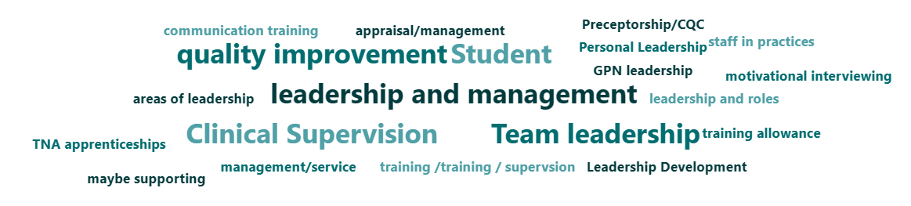

The above image is a word cloud generated by the most common words associated with what should be in a Leadership Toolkit and has helped to form the premise of this toolkit. Another question that was asked was how important a document such as this one would be for lead GPN, the image below shows the response.

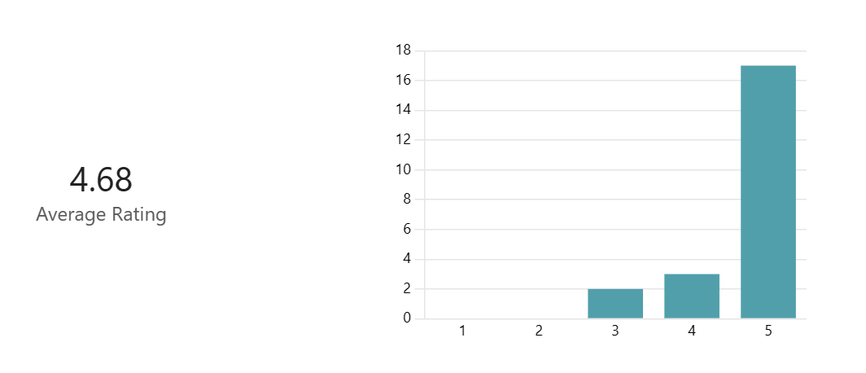

## Area 1: Compassionate Leadership

Compassionate Leadership is a style of leadership that focuses on the empathetic and wellbeing side of supporting others, this can be done be being an enabler and enabling others to feel listened to and feel that their contribution is valued as discussed by Bailey and West (2022).

**Compassionate Leaders in Primary Care**

The following links will take you to a series of podcasts by the NHS Leadership Academy regarding compassionate leadership, these focus on the importance of self-compassion, being an advocate for patients and staff and that each clinical and non-clinical role plays a part in leadership.

The first podcast is based on the compassionate leadership style being used in primary care and underlines the importance of self-compassion. The following two podcasts touch further on developing these compassionate skills in our leaders to prepare us for the future and discusses the importance of embedding a culture of compassion.

[Leadership Listens 7 – Compassion in primary care – Leadership Academy](https://learninghub.leadershipacademy.nhs.uk/leadership/leadership-listens-7/)

[Leadership Listens 6 – The importance of compassion in developing leaders – Leadership Academy](https://learninghub.leadershipacademy.nhs.uk/leadership/leadership-listens-6/)

[Leadership Listens 3 – Creating a compassionate culture in organisations – Leadership Academy](https://learninghub.leadershipacademy.nhs.uk/leadership/leadership-listens-3/)

Pehlivan and Guner (2020) reviewed literature discussing compassionate leadership and found that there were numerous positive effects on patient care when compassionate leadership was used by clinicians and non-clinicians involved in their care.

**Online Courses for Compassionate Leadership**

The following link takes you to a free online course run by The King’s Fund (2024) [Leading With Compassion | Free Course | The King's Fund (kingsfund.org.uk).](https://www.kingsfund.org.uk/leadership-development/courses/leading-kindness-compassion-health-social-care) It can be done online, suggests it takes up to three weeks and is able to be accessed be established leaders, those who are new to a leadership position, and other members of staff who aren’t yet in a leadership position but wish to understand more about compassionate leadership.

Another free module which can be accessed is run by the NHS Leadership Academy (2024a) [Compassionate leadership in crisis – Leadership Academy.](https://learninghub.leadershipacademy.nhs.uk/guides/compassionate-leadership-in-crisis/) This bitesize module helps leaders and manager understand how to thrive in crises with compassionate head on.

McCrudden Training (2024) offer a more intensive training course which consists of 4 x 3.5-hour virtual workshop sessions. Sessions will consist of developing compassionate leadership awareness, becoming more self-aware and learning how to balance empathy. The following link will take you to this training learning opportunity: [Lead with Compassion: In Practice - McCrudden Training.](https://mccruddentraining.co.uk/leadership-programmes/lead-with-compassion-in-practice/)



## Area 2: Difficult Conversations

As nurses we are used to and are equipped with the knowledge and training of speaking to patients and dealing with difficult clinical conversations, breaking bad news and discussing treatment options. But difficult conversations can also happen for non-clinical reasons, difference of opinions can spark the start of a difficult conversation or a breakdown of communication. In a leadership position diffusing these situations is paramount, whether it be from a clinical or non-clinical background.

**Conversation Structures**

The Centre for Creative Leadership (2024) comments on the three errors that are normally made in conversations which can help difficult conversation form happening or can help to avoid and to structure the conversation better if you know what these errors are. These three errors are:

* Assuming we know all the information
* Hiding our feelings
* Ignoring who we are- acting differently than what we think.



**Online courses for handling difficult conversations**

The following two links will take you to two bitesize modules created by the NHS Leadership Academy regarding difficult conversations in different contexts.

The first being about having courageous conversations and preparing for conversations that you are apprehensive about [Courageous Conversations – Leadership Academy.](https://learninghub.leadershipacademy.nhs.uk/guides/courageous-conversations/) (NHS Leadership Academy, 2024b).

The second being targeted around painful conversations with peers and staff [Conversations about painful subjects – Leadership Academy](https://learninghub.leadershipacademy.nhs.uk/guides/conversations-about-painful-subjects/) (NHS Leadership Academy, 2024c).



As well as the bitesize modules there is also a Ted Talk (TED Global, 2012) from Margaret Heffernan who is a CEO, writer and keynote speaker. Margaret talk is titled ‘Dare to Disagree’ and is an interesting watch and really makes you think about disagreements and difficult conversations in a different way, and that it can be a positive. The following link will take you there: [Margaret Heffernan: Dare to disagree | TED Talk.](https://www.ted.com/talks/margaret_heffernan_dare_to_disagree)

## Area 3: Conducting Appraisal’s

Appraisals are an opportunity for two individuals to sit down and discuss all the positive and negative aspects of the appraisee’s work life and their developmental journey as stated by the Royal College of Nursing (RCN, 2024a). As an Appraiser it is your responsibility to listen and to support appraisee’s through making developmental decisions but learning how to conduct this can be challenging for first time appraisers or when an appraisal does not navigate in a planned way.

**Appraisal Background**

Appraisals are meant to be conducted every 12 months and is good chance to discuss and reflect on the previous 12 months and to focus on plans for the next 12 months.

For nurse’s who are becoming appraisers for the first time, initial appraisal training can be accessed from several different training providers dependant on locality and practice preference.

The following link shares a few training videos regarding ways to conduct appraisals to achieve the best outcome for the appraisee, [NHS England » Clinical appraisal skills video workshops](https://www.england.nhs.uk/professional-standards/medical-revalidation/appraisers/video-workshops/) (NHS England, 2024a). The videos were originally set up for medical appraisals however the general themes of how to approach certain questions and how to respond and act to encourage the appraisee.



**E-Learning for Appraisals**

NHS England have created an e-learning module on their E-Learning for health care platform, called ‘Having confident Appraisals’ (NHS England, 2024b), this can be accessed using the following link [Having Confident Appraisal Conversations - elearning for healthcare (e-lfh.org.uk).](https://www.e-lfh.org.uk/programmes/having-confident-appraisal-conversations/)

**Appraisal Preparation tips**

Preparing for an appraisal as an appraiser or as an appraisee is just as important as the appraisal itself. Ensuring enough time and thought has been allocated for the necessary preparations for the appraisal will add to the value and confidence of performance during the session. Below is a list of tips for the appraiser and appraisee to help with preparing for the appraisal.

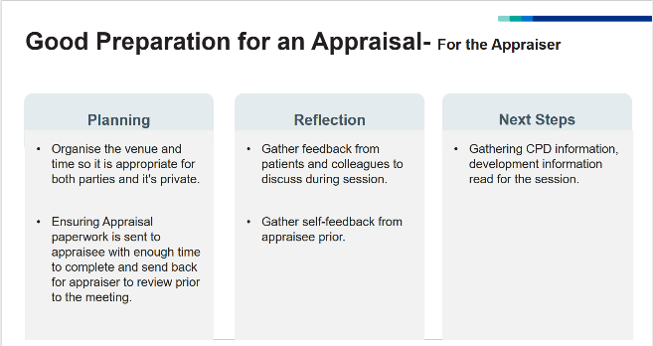 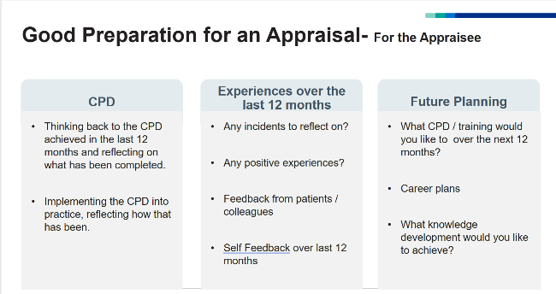

These tips can be used from a lead nurse perspective as an appraiser during appraisals for other clinicians and the tips for the appraisee can be shared with the nursing team to help prepare for their appraisals. These can also be used by lead nurses for their own appraisals.

**Smart objectives**

Smart objectives can be used during an appraisal to plan for the next 12 months in terms of development and CPD. Smart stands for Specific, Measurable, achievable, Relevant and Time-bound. This style of objective setting can be used when discussing the goals with an appraisee to ensure these goas align and are within scope of practice.

Please see below for a table describing the different elements of SMART objectives.

|  |  |
| --- | --- |
| SPECIFIC | Describe the desired goal: Analyse, Determine, Perform.  Who will be responsible? Is the outcome clear? When will it happen? |
| MEASUREABLE | How will it be measured? How can the measurements be obtained? |
| ACHIEVABLE | Do you know it is measurable? Has it been done before? Are the resources available? |
| RELEVANT | Are they linked to aims? Do they support goals? |
| TIME-BOUND | When does it need to be completed by? |

## Area 4: Quality Improvement

Quality Improvement effects all healthcare clinicians and exists to problem solve issues relating to health care whether they be directly patient focused or issues involving staff for example retention or wellbeing. Quality improvement is when the time is given to those individuals wanting to make a change to investigate the resources and skills needed to solve a problem (The Health Foundation, 2019).

Quality improvement can be undertaken by any clinician, historically this might have been doctors / medics, however nurses and other clinicians are becoming more involved.

**Quality Improvement Process**

The following links are resources detailing the process of quality improvement in healthcare, the first one is from The Health Foundation which explains the methodologies, principles and answers many questions.

[Quality improvement made simple - The Health Foundation](https://www.health.org.uk/publications/quality-improvement-made-simple)

The following two links are documents created by NHS England, one which is specifically created for general practice (NHS England, 2019) and one which is a handbook for quality and improvement service tools (NHS England, 2010).

[an-introduction-to-quality-improvement-in-general-practice.pdf (england.nhs.uk)](https://www.england.nhs.uk/wp-content/uploads/2019/03/an-introduction-to-quality-improvement-in-general-practice.pdf)

[the_handbook_of_quality_and_service_improvement_tools_2010-2.pdf (england.nhs.uk)](https://www.england.nhs.uk/commissioning/wp-content/uploads/sites/44/2017/11/the_handbook_of_quality_and_service_improvement_tools_2010-2.pdf)

NHS England (2018) also produced a change management model guide which is handy guide to helping go through quality improvement and change management processes whether that be small or large ideas. This can be accessed on the following link: [change-model-guide-v5.pdf (england.nhs.uk)](https://www.england.nhs.uk/wp-content/uploads/2018/04/change-model-guide-v5.pdf)

**Quality Improvement Training**

There are several training courses and providers who specialize in quality improvement, and this might differ depending on the area your based on, so check with your local training hub to see the quality improvement training opportunities that are currently active.

The Improvement Academy (2022) offers a free bronze level e-learning introduction to quality improvement which can be accessed by all healthcare workers.

[Quality Improvement Training - Bronze - Improvement Academy](https://improvementacademy.org/e-learning/quality-improvement-training-bronze/)

There is further opportunity to do the further stages once the bronze level has been completed, all this information is provided on the e-learning page. To access the training an account will need to be created, a certificate can be printed off for CPD hours.

Another e-learning course which offers an introduction to quality improvement is run by NHS Elect (2024), this course has six modules and approximately lasts four hours.

It can be accessed on the following link: [NHS Elect.](https://www.nhselect.nhs.uk/online_training_courses_detail.aspx?sectionID=1)

E-Learning for Healthcare (2024c) also have created an e-learning module which incorporates quality, research and audit. There are two separate modules to complete, and they can be found using this link [Research, Audit and Quality Improvement - elearning for healthcare (e-lfh.org.uk)](https://www.e-lfh.org.uk/programmes/research-audit-and-quality-improvement/)



## Area 5: Preparing for a CQC inspection as a lead nurse

Having a CQC (Care Quality Commission) inspection can be a daunting experience if it is your first time in a leadership position or if it is your tenth time. This following chapter should help identify some areas which CQC are keen to investigate during their inspection, to help alleviate pressure and help you prepare for any upcoming inspections.

**CQC Requirements**

CQC (2022) itself has discussed the requirements they look for regarding General Practice Nurses as a whole, these can be found on the following link:

[GP mythbuster 26: General practice nurses - Care Quality Commission (cqc.org.uk)](https://www.cqc.org.uk/guidance-providers/gps/gp-mythbusters/gp-mythbuster-26-practice-nurses)

Key points from this extract are:

* Assurance of the Competence of the general practice nursing team.
* Appraisals have been conducted for staff in the last 12 months.
* All Nurses and nursing Associates have current registration with the NMC (Nursing and Midwifery Council) and opportunity for revalidation to happen.
* Nurses are given the chance to develop.

When the inspection takes place, these might be a few of the topic areas which they would like to discuss with you.

CQC (2023) have also created this handy guide which ‘Myth Busters’ common questions about the CQC inspection for General Practice, many of these will involve the nursing team and as lead for the team you may be asked to talk about them, give updates or show evidence. The link for the ‘Myth Busters’ is below:

[GP mythbusters - Care Quality Commission (cqc.org.uk)](https://www.cqc.org.uk/guidance-providers/gps/gp-mythbusters)

The British Medical Association (BMA, 2023) have also produced a document on preparing for a CQC inspection. Although a lot of the document has been created for the purpose of medical staff or practice managers, there are a few areas of interest for a GPN Lead, such as a checklist of items which will help with vaccine’s/ medications and doctors' bags. This can be found here:

[How to prepare for a CQC inspection (bma.org.uk)](https://www.bma.org.uk/advice-and-support/gp-practices/the-cqc/how-to-prepare-for-a-cqc-inspection)

**CQC Domains**

There are four main areas which are covered by CQC, and these are:

1. Safety
2. Effectiveness
3. Patient Care
4. Leadership

Below is a list of questions split into the four areas which may be asked by CQC to start thinking about. This list is not exhaustive and isn’t all the questions, just an idea to start thinking with a CQC mind.

|  |
| --- |
| **Safety** |
| Who is the Lead for Infection Control, and where is the infection control policy? |
| Who is responsible for the cold chain, is there a cold chain process? |
| How do you handle Specimen's? |
| What is the process for sharp’s injuries? |
| Who is the Lead for Safeguarding? |
| Are all staff DBS checked? |
| Do you have a chaperoning policy? |
| Where are your medications stored? |
| **Effectiveness** |
| How are nursing staff recruited? |
| Do you know what training is needed for staff’s CPD? |
| How do you refer to other services? |
| **Patient Care** |
| How do you ensure privacy, dignity and diversity is respected? |
| How do you address language barriers? |
| How do you know you are being effective? |
| **Leadership** |
| What is the culture like? |
| Where are the practice policies and procedures kept, and who has access to them? |
| What happens in practice meetings? |

## Area 6: Leading the next generation of the Nursing workforce

As a General Practice Nurse, teaching and education plays a part in everyday life having to teach patients and educate on different activities such as inhaler technique or weight management for example. This education side can also be applied to students, whether that be undergraduate nurses, student nursing associates, postgraduate nurses or other clinicians who are having insight visit with the nursing team.

**Standards for Student Supervision and Assessment (SSSA)Training**

SSSA training is required by nurses before they accept students into their area, this is to ensure clinicians have had the appropriate training and are prepared to create a suitable educational experience for their students.

There are two elements to the SSSA training, one being the Supervisor training, this is the level the undergraduate nurse’s now leave university with on completion of the nursing degree. Being a supervisor means that you can take a student and educate but aren’t able to carry out any assessments.

The second element which requires additional training is for the Assessor part, once completed this role enables nurse’s to not only supervise students but to assess at all points through their educational journey and to carry out the start, mid and end point assessments.

SSSA training can be undertaken through your local training hub or local Higher Educational Institute, contact your local services for more information and support regarding this.

NMC (2023) has published three parts of its standards for nursing and midwifery education which are found on the links below:

[Standards framework for nursing and midwifery education - The Nursing and Midwifery Council (nmc.org.uk)](https://www.nmc.org.uk/standards-for-education-and-training/standards-framework-for-nursing-and-midwifery-education/)

[Standards for student supervision and assessment - The Nursing and Midwifery Council (nmc.org.uk)](https://www.nmc.org.uk/standards-for-education-and-training/standards-for-student-supervision-and-assessment/)

[Standards for pre-registration nursing programmes - The Nursing and Midwifery Council (nmc.org.uk)](https://www.nmc.org.uk/standards/standards-for-nurses/standards-for-pre-registration-nursing-programmes/)

**SLEC- Safe Learning Environment Charter**

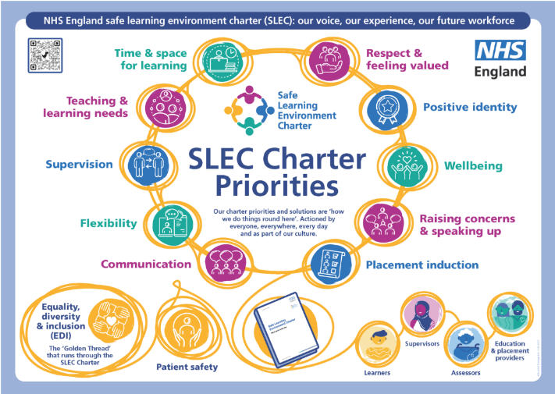

NHS England (2024d) have developed the SLEC charter (Safe Learning Environment Charter). This has been created in response to healthcare learners feedback from their clinical experiences in maternity settings. These experiences have been discussed in both the Kirkup (2015 and 2022) reports and the Ockendon (2020 and 2022) reports.

The charter encompasses 10 key areas and golden thread elements which have all been identified as key and important to create a safe environment for students to learn in. NHS England (2024d) have created resources and have explained the purpose of the SLEC charter alongside background and context on the following link [NHS England » Safe Learning Environment Charter – what good looks like.](https://www.england.nhs.uk/long-read/safe-learning-environment-charter/#next-steps)

The charter although has been created from a maternity student response has been designed multi-disciplinary and to be used by all areas that students may access.

## Area 7: Professional Nurse Advocate

The Professional Nurse Advocate (PNA) role is one which is new, especially regarding a general practice viewpoint. A PNA uses the A-Equip model (NHS England, 2023b), A-Equip stands for Advocating and Educating for Quality Improvement. The role uses A-Equip to achieve four functions:

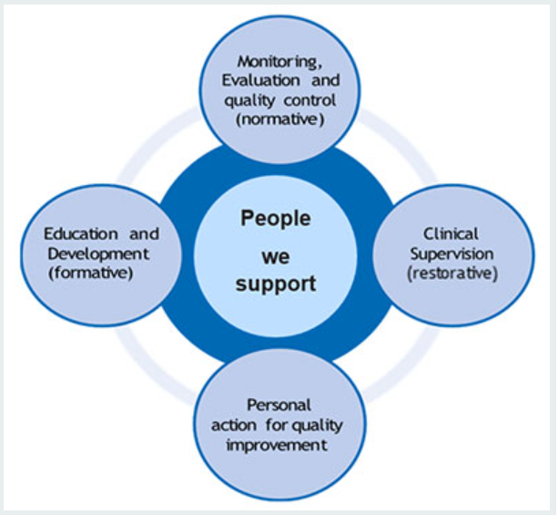

1. Monitoring and Evaluation and Quality Control (Normative)
2. Clinical Supervision (Restorative)
3. Personal Action for Quality Improvement
4. Education and Development (Formative)

Restorative Clinical Supervision is facilitated by PNA’s to other nurses to encourage and empower self-development and to inspire involvement with quality improvement initiatives.

**PNA Contacts**

For the Midlands there is a regional lead:

* Lead: Joanne Watson
* Email: [midlands.pna@nhs.net](mailto:midlands.pna@nhs.net)

There will also be a PNA link or an individual who will be able to advise about PNA’s at your local training hub- whether that is an enquiry about becoming a PNA or an enquiry about accessing a restorative clinical supervision session.

For more information about the PNA role, please see the following link from NHS England (2024e)[NHS England » Professional nurse advocate](https://www.england.nhs.uk/nursingmidwifery/delivering-the-nhs-ltp/professional-nurse-advocate/)

## Area 8: Preceptorship

Being a lead nurse in charge of a nursing team means supporting newly qualified nurses and nursing associates or new to general practice into their primary care position. Many of these clinicians will be seeking support from their lead as they integrate into their new area. Preceptorship is a period of time given to nurses new to an area, mainly newly qualified nurses in which they get support and build their confidence (Nursing and Midwifery Council, 2024).

The Nursing and Midwifery Council (NMC) has discussed the importance and different elements of Preceptorship including the benefits on the following link [Principles of preceptorship - The Nursing and Midwifery Council (nmc.org.uk).](https://www.nmc.org.uk/standards/guidance/preceptorship/) The NMC states there are five core themes of Preceptorship:

1. Organisational culture and preceptorship
2. Quality, and oversight of preceptorship
3. Preceptee empowerment
4. Preparing preceptors for their supporting role
5. Preceptorship programme

Preceptorship usually takes place over the first 12 months of a newly qualified nurse or nurse associate's career. The process will involve the preceptee being assigned a preceptor for the duration of the time to have reflective discussions, reviews and to act as a supportive pillar who encourages self-development. The preceptor can be a direct colleague or can also be from another department.

**Benefits of Preceptorship**

Preceptorship can give many benefits not only to the preceptee but to the area they are starting in, some of these benefits are listed below:

* Structured support
* Chance to reflect
* Gaining knowledge as well as clinical skills development
* Sense of belonging
* Increased retention
* Retaining nurses into the same workplace

**NHS England National Preceptorship Framework**

NHS England have produced a national preceptorship framework (NHS England, 2022a) and model (NHS England, 2022b) to be used and adapted to suit specific departmental needs by a range of settings. This can be acute, primary and community settings.

The framework goes into detail about the different elements of preceptorship and discusses the importance of each element and how it can be completed in a workplace. The framework can be reached on the following link: [B1918_i_National-preceptorship-framework-for-nursing-10-October-2022.pdf (workforceskills.nhs.uk).](https://workforceskills.nhs.uk/wp-content/uploads/2022/10/B1918_i_National-preceptorship-framework-for-nursing-10-October-2022.pdf)

The model can be transferable to all settings and gives the minimum core standard and gold standard examples of what a preceptorship should look like. This can be found and the following link: [B1918_ii_National-preceptorship-model-for-nursing-October-2022.pdf (workforceskills.nhs.uk).](https://workforceskills.nhs.uk/wp-content/uploads/2022/10/B1918_ii_National-preceptorship-model-for-nursing-October-2022.pdf)

**The Queens Nursing Institute**

The Queen’s Nursing Institute (QNI, 2020a) have also created a template for preceptorship which can be used as either a guide or as a document to facilitate preceptorship sessions. The document has a variety of sections to aid with catch up sessions and the structure of the preceptorship programme in practice. This document can be found on the following link: [General-Practice-Nursing-Induction-Template.pdf (qni.org.uk)](https://qni.org.uk/wp-content/uploads/2019/05/General-Practice-Nursing-Induction-Template.pdf)

One example of a section in this document which is very useful is the following section which is a chart that can be ticked off to highlight training completed and what else could be completed to help with developmental goals.

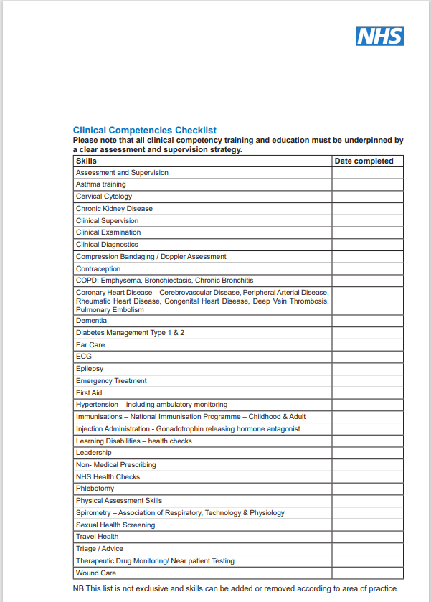

The Queens Nursing Institute have also created a document called ‘The Standards of Education and Practice for Nurses new to General Practice Nursing (QNI, 2020b). These standards have been produced by the QNI on request of NHS   
England to aid and provide structure to those clinicians who are starting their career in general practice. This document ca be found on the following link: [Standards-of-Education-and-Practice-for-Nurses-New-to-General-Practice-Nursing.pdf (qni.org.uk)](https://qni.org.uk/wp-content/uploads/2020/05/Standards-of-Education-and-Practice-for-Nurses-New-to-General-Practice-Nursing.pdf)

## Area 9: Wellbeing

It is important as lead nurses to look after your own personal wellbeing and be able to signpost and advocate for other nursing colleagues to look after their own wellbeing. The pressures of managing a team combined with patient and capacity demand mixed with external pressures can get too much and it is vitally important to take care and manage mental health and wellbeing or know where to access.

The NHS People Plan (NHS England, 2020) sets out that the health and wellbeing of clinicians is vitally important and there is a great focus. The People Plan also states the health and wellbeing of staff is just as important as the other amazing outputs that the NHS produces.

**Royal College of Nursing**

The Royal College of Nursing (2024b) has created a page on its website dedicated to wellbeing support for nurses and nurse associates. The page has lots of further links and resources on to help manage different types of issues that may arise. The following link takes you to that page: [Supporting your mental wellbeing | RCN Counselling Service | Royal College of Nursing.](https://www.rcn.org.uk/get-help/member-support-services/counselling-service/covid-19-and-your-mental-wellbeing)

There is a further webpage created by the Royal College of Nursing (2024c) which offers a range of different literature regarding different wellbeing support that might be needed. This can be accessed on the following link: [Wellbeing Self Care and Resilience | Subject Guide | Royal College of Nursing (rcn.org.uk).](https://www.rcn.org.uk/library/subject-guides/Wellbeing-Self-Care-and-Resilience)

**Nursing Times**

The Nursing Times have gathered a large range of information into one zone, the information provided is a range of articles, videos and recorded webinars to watch and gain wellbeing support from. All the latest information will appear on this page and is accessible for any nurse or nursing associate (Nursing Times, 2024). This page can be accessed on this link: [Wellbeing for nurses | Nursing Times.](https://www.nursingtimes.net/clinical-archive/wellbeing-for-nurses/)

## Area 10: Recruitment

Being a lead nurse will lead to being involved with different elements that you may not have had to be involved with before, one of these elements being to help with the recruitment and interview process of new members of the nursing team. This will mean being involved with the following items:

* Assisting or solely writing the job description to be seen by applicants.
* Narrowing down the applicants to the interview stages.
* Assisting or solely conducting and leading the interviews for the position.
* Shortlisting after interviews and informing applicants of decisions.
* Ensuring that all the relevant HR elements of recruitment are completed such as references received, immunisations up to date for clinical staff and reasonable adjustments have been accounted for if needed. Some organisations may have their own HR lead who does specific part as well as looking at the financial elements.
* Ensuring the new member of staff receives an induction into their new workplace and is offered the support that they need.

Observing interviews being conducted can help to prepare for carrying out your own interviews, equally own experiences of bad interviews and good interviews that you have been part of will help to shape how you act and perform being the interviewer.

Health Education England (2023) have written a page on their website which is aimed at individuals preparing for an interview as it discusses what interviewers are expecting, unwritten rules and preparing. However, it is very useful from an interviewer's perspective. This information can be found on this link: [Having A Successful Interview | NHS England | Workforce, training and education (hee.nhs.uk).](https://www.hee.nhs.uk/about-2/work-us/hee-applicant-guide/having-successful-interview)

## Area 11: Leading Meetings

A big part of being a lead nurse is not only attending meetings but leading nurse meetings and potentially other meetings when required. Some lead nurses who are new to post might not have experienced this before and might feel that it’s a daunting prospect and might feel nervous or might not know where to begin with planning for such meeting.

These meetings could be monthly nurse team meetings where reflection and next steps are discussed in an open forum and as a team, the meetings could also be an educational one or a multi-disciplinary type of meeting.

Nurse.com (2009) have created a nine-tip list for effective leaders, these tips are outlined below:

1. Scheduling when it’s appropriate for the individuals to attend.
2. Prepare the agenda.
3. Start and end the meeting on time.
4. Set the tone for the meeting from the start.
5. Communicate powerfully.
6. Focus the discussion.
7. Redirect negativity.
8. Train meeting leaders

NHS Improvement (2019) have created a framework for clinical leaders, although it is aimed at senior leaders much of the information can be transferred. During this framework there is information regarding holding meetings and how to become competent in this, one of the suggestions is to shadow meetings to pick up on good and bad behaviours. The framework can be found on this following link: [clinical-leadership-framework.pdf (england.nhs.uk).](https://www.england.nhs.uk/wp-content/uploads/2021/05/clinical-leadership-framework.pdf)

## References

Bailey, S. and West, M. (2022), *What is Compassionate Leadership,* Available at: [What Is Compassionate Leadership? | The King's Fund (kingsfund.org.uk),](https://www.kingsfund.org.uk/insight-and-analysis/long-reads/what-is-compassionate-leadership) (Last Accessed: 13/03/2024).

Balluck, J. (2023). "Increasing Nurse Leaders Competence and Confidence by Implementing a Novice Nurse Leader Development Program." Nurse Leader 21(3): pp:22-27.

British Medical Association. (2023) *How to Prepare for a CQC Inspection.* Available at: [How to prepare for a CQC inspection (bma.org.uk).](https://www.bma.org.uk/advice-and-support/gp-practices/the-cqc/how-to-prepare-for-a-cqc-inspection) (Last Accessed: 10/04/2024).

Care Quality Commission. (2022) *GP Myth buster 26: General Practice Nurses.* Available at: [GP mythbuster 26: General practice nurses - Care Quality Commission (cqc.org.uk)](https://www.cqc.org.uk/guidance-providers/gps/gp-mythbusters/gp-mythbuster-26-practice-nurses) (Last Accessed: 10/04/2024).

Care Quality Commission. (2023) *GP MythBusters.* Available at: [GP mythbusters - Care Quality Commission (cqc.org.uk).](https://www.cqc.org.uk/guidance-providers/gps/gp-mythbusters) (Last Accessed: 10/04/2024).

Centre for Creative Leadership, (2024), *“5 Steps for Tackling Difficult Conversations”.* Available at: [How to Tackle Difficult Conversations | CCL.](https://www.ccl.org/articles/leading-effectively-articles/5-steps-for-tackling-tough-conversations/) (Last Accessed: 18/03/2024).

Clifford, J. Barnes, K. Arora, R. Raouf, S. (2021) *Leading the Way: The Role and Values of Nurses in General Practice in England.* Available at: [Leading-the-way_The-role-and-value-of-nurses-in-general-practice-in-England-2021_Publication-version.pdf (sonnetimpact.co.uk).](https://sonnetimpact.co.uk/wp-content/uploads/2022/02/Leading-the-way_The-role-and-value-of-nurses-in-general-practice-in-England-2021_Publication-version.pdf) (Last Accessed: 16/04/2024).

Fitzpatrick, J. J., et al. (2016). "A Leadership Education and Development Program for Clinical Nurses." JONA: The Journal of Nursing Administration 46(11): 561-565.

Health Education England (2019) *Primary Care and General Practice Nursing Career and ~Core Capabilities Framework,* [online] Available at: [Report template (skillsforhealth.org.uk).](https://www.skillsforhealth.org.uk/wp-content/uploads/2022/05/Primary-Care-and-GPN-Framework-May22.pdf) [Accessed: 24/04/2024].

Health Education England (2023) *Having a Successful Interview*, Available at: [Having A Successful Interview | NHS England | Workforce, training and education (hee.nhs.uk).](https://www.hee.nhs.uk/about-2/work-us/hee-applicant-guide/having-successful-interview) [Accessed 24/04/2023].

Improvement Academy, (2022). *Quality Improvement Training- Bronze,* Available at: [Quality Improvement Training - Bronze - Improvement Academy,](https://improvementacademy.org/e-learning/quality-improvement-training-bronze/) (Last Accessed: 08/04/2024).

Kirkup, B. (2015) *Morecambe Bay Investigation Report,* Available at: [Morecambe Bay Investigation: Report - GOV.UK (www.gov.uk).](https://www.gov.uk/government/publications/morecambe-bay-investigation-report) (Last Accessed: 16/04/2024).

Kirkup, B. (2022) *Maternity and Neonatal Services in East Kent: ‘Reading the Signals’ Report,* Available at: [Maternity and neonatal services in East Kent: 'Reading the signals' report - GOV.UK (www.gov.uk).](https://www.gov.uk/government/publications/maternity-and-neonatal-services-in-east-kent-reading-the-signals-report) (Last Accessed: 16/04/2024).

McCrudden Training, (2024), *“Lead with Compassion: In Practice”*, Available at: [Lead with Compassion: In Practice - McCrudden Training,](https://mccruddentraining.co.uk/leadership-programmes/lead-with-compassion-in-practice/) (Last Accessed: 18/03/2024).

NHS Digital, (2024), *Appointments in General Practice, November 2023,* Available at: [Appointments in General Practice, November 2023 - NHS Digital,](https://digital.nhs.uk/data-and-information/publications/statistical/appointments-in-general-practice/november-2023) (Last Accessed: 07/02/2024).

NHS Elect, (2024), *Intro to Quality Improvement,* Available at: [NHS Elect,](https://www.nhselect.nhs.uk/online_training_courses_detail.aspx?sectionID=1) (Last Accessed: 08/04/2024).

NHS England, (2023a), N*HS Long Term Workforce Plan,* Available at: [NHS Long Term Workforce Plan (england.nhs.uk).](https://www.england.nhs.uk/wp-content/uploads/2023/06/nhs-long-term-workforce-plan-v1.2.pdf) (Last Accessed 06/02/2024).

NHS England, (2023b), *Professional Nurse Advocate A-Equip Model: A Model of Clinical Supervision for Nurses.* Available at: [NHS England » Professional nurse advocate A-EQUIP model: a model of clinical supervision for nurses.](https://www.england.nhs.uk/long-read/pna-equip-model-a-model-of-clinical-supervision-for-nurses/) (Last Accessed: 10/04/2024).

NHS England, (2024a), *Clinical Appraisal Skills Video Workshops*, Available at: [NHS England » Clinical appraisal skills video workshops.](https://www.england.nhs.uk/professional-standards/medical-revalidation/appraisers/video-workshops/) (Last Accessed 25/03/2024).

NHS England, (2024b), *Having Confident Appraisals Conversations*, Available at: [Having Confident Appraisal Conversations - elearning for healthcare (e-lfh.org.uk).](https://www.e-lfh.org.uk/programmes/having-confident-appraisal-conversations/) (Last Accessed 25/03/2024).

NHS England, (2024c), *Research, Audit and Quality Improvement,* Available at: [Research, Audit and Quality Improvement - elearning for healthcare (e-lfh.org.uk).](https://www.e-lfh.org.uk/programmes/research-audit-and-quality-improvement/) (Last Accessed 08/04/2024).

NHS England, (2024d) *Safe Learning Environment Charter- What Good Looks like,* Available at: [NHS England » Safe Learning Environment Charter – what good looks like.](https://www.england.nhs.uk/long-read/safe-learning-environment-charter/) (Last Accessed: 16/04/2024).

NHS England, (2024e) *Professional Nurse Advocate,* Available at: [NHS England » Professional nurse advocate](https://www.england.nhs.uk/nursingmidwifery/delivering-the-nhs-ltp/professional-nurse-advocate/) (Last Accessed: 10/04/2024).

NHS England, (2022a) *National Preceptorship Framework for Nursing,* [online] Available at: [B1918_i_National-preceptorship-framework-for-nursing-10-October-2022.pdf (workforceskills.nhs.uk).](https://workforceskills.nhs.uk/wp-content/uploads/2022/10/B1918_i_National-preceptorship-framework-for-nursing-10-October-2022.pdf) [Accessed: 22/04/2024]

NHS England, (2022b) *National Preceptorship Model for Nursing,* [online] Available at: [B1918_ii_National-preceptorship-model-for-nursing-October-2022.pdf (workforceskills.nhs.uk).](https://workforceskills.nhs.uk/wp-content/uploads/2022/10/B1918_ii_National-preceptorship-model-for-nursing-October-2022.pdf) [Accessed: 22/04/2024].

NHS England, (2020) *We are the NHS: People Plan 2020/21- action for us all.* [online] Available at: [We-Are-The-NHS-Action-For-All-Of-Us-FINAL-March-21.pdf (england.nhs.uk)](https://www.england.nhs.uk/wp-content/uploads/2020/07/We-Are-The-NHS-Action-For-All-Of-Us-FINAL-March-21.pdf) [Accessed: 23/04/2024].

NHS England (2018) *Sustainable Improvement Team. The Change Management Model.* [online] Available at: [change-model-guide-v5.pdf (england.nhs.uk)](https://www.england.nhs.uk/wp-content/uploads/2018/04/change-model-guide-v5.pdf) [Accessed: 24/04/2024].

NHS Improvement (2019) *Clinical Leadership- a Framework for Action. A Guide for Senior Leaders on Developing Professional Diversity at Board Level,* [online] Available at: [clinical-leadership-framework.pdf (england.nhs.uk).](https://www.england.nhs.uk/wp-content/uploads/2021/05/clinical-leadership-framework.pdf) [Accessed 24/04/2024].

NHS Leadership Academy, (2024a), *Compassionate Leadership in Crisis,* Availableat*:* [Compassionate leadership in crisis – Leadership Academy](https://learninghub.leadershipacademy.nhs.uk/guides/compassionate-leadership-in-crisis/) (Last Accessed 18/03/2024).

NHS Leadership Academy, (2024b), *Courageous Conversations*, Available at: [Courageous Conversations – Leadership Academy.](https://learninghub.leadershipacademy.nhs.uk/guides/courageous-conversations/) (Last Accessed 25/03/2024).

NHS Leadership Academy, (2024c), *Conversations about Painful Subjects,* Available at: [Conversations about painful subjects – Leadership Academy.](https://learninghub.leadershipacademy.nhs.uk/guides/conversations-about-painful-subjects/) (Last Accessed 25/03/2024).

NHS England (2019) *An Introduction to Quality Improvement in General Practice* [Online]. Available at: an-introduction-to-quality-improvement-in-general-practice.pdf (england.nhs.uk) (Last Accessed 03/04/2024).

NHS England (2010) *The Handbook of Quality and Service Improvement Tools*. [Online]. Available at: [the_handbook_of_quality_and_service_improvement_tools_2010-2.pdf (england.nhs.uk).](https://www.england.nhs.uk/commissioning/wp-content/uploads/sites/44/2017/11/the_handbook_of_quality_and_service_improvement_tools_2010-2.pdf) [Accessed 04/04/2024].

Nurse.com (2009) *Nine Tips for Leading Effective Meetings*, Available at: [Nine Tips for Leading Effective Meetings | Nurse.com.](https://www.nurse.com/blog/nine-tips-for-leading-effective-meetings/) [Accessed: 24/04/2024].

Nursing and Midwifery Council (2023) *Standards for Education and Training*. Available at: [Standards for education and training - The Nursing and Midwifery Council (nmc.org.uk).](https://www.nmc.org.uk/standards-for-education-and-training/) (Last Accessed 10/04/2024).

Nursing and Midwifery Council (2024) *Principles of Preceptorship*, Available at: [Principles of preceptorship - The Nursing and Midwifery Council (nmc.org.uk).](https://www.nmc.org.uk/standards/guidance/preceptorship/) [Accessed: 22/04/2024].

Nursing Times (2024) *Wellbeing for Nurses,* Available at: [Wellbeing for nurses | Nursing Times.](https://www.nursingtimes.net/clinical-archive/wellbeing-for-nurses/) [Accessed 23/04/2024].

Nieuwboer, M., et al. (2022). "Clinical leadership training in integrated primary care networks: a qualitative evaluation." *Integrated Healthcare Journal* .4(1): e000086.

Ockenden, D. (2020) *Ockenden Review of Maternity Services at Shrewsbury and Telford Hospital NHS Trust.* Available at: [Ockenden review of maternity services at Shrewsbury and Telford Hospital NHS Trust - GOV.UK (www.gov.uk).](https://www.gov.uk/government/publications/ockenden-review-of-maternity-services-at-shrewsbury-and-telford-hospital-nhs-trust) (Last Accessed: 16/04/2024).

Ockenden, D. (2022) *Final Report of the Ockenden Review,* Available at: [Final report of the Ockenden review - GOV.UK (www.gov.uk).](https://www.gov.uk/government/publications/final-report-of-the-ockenden-review) (Last Accessed: 16/04/2024).

Pehilvan, T. Guner, P. (2020). “Compassionate Care: Benefits, Barriers and recommendations”. *Journal of Psychiatric Nursing*. 11(2). pp:148-153.

Power, A., et al. (2017). "An evaluation of experiences and views of Scottish leadership training opportunities amongst primary care professionals." Education for Primary Care 28(3): pp:159-164.

Royal College of Nursing, (2024a), *Appraisals and Performance reviews: How to prepare,* Available at: [Appraisals and performance reviews: a checklist to help you prepare | Royal College of Nursing (rcn.org.uk).](https://www.rcn.org.uk/Get-Help/RCN-advice/appraisals-and-performance-reviews-checklist) (Lase Accessed 25/03/2024).

Royal College of Nursing, (2024b) *Supporting your Mental Wellbeing*, Available at: [Supporting your mental wellbeing | RCN Counselling Service | Royal College of Nursing.](https://www.rcn.org.uk/get-help/member-support-services/counselling-service/covid-19-and-your-mental-wellbeing) [Accessed 23/04/2024].

Royal College of Nursing (2024c) *Wellbeing, Self-Care and Resilience,* Available at: [Leadership Toolkit for General Practice Nurse’s.docx (sharepoint.com).](https://nhs-my.sharepoint.com/:w:/r/personal/charlotte_darby4_nhs_net/_layouts/15/Doc.aspx?sourcedoc=%7B94142B75-10F1-492B-8B0A-36663E4ACEF1%7D&file=Leadership%20Toolkit%20for%20General%20Practice%20Nurse%E2%80%99s.docx&action=default&mobileredirect=true&DefaultItemOpen=1&login_hint=charlotte.darby4%40nhs.net&ct=1713877157011&wdOrigin=OFFICECOM-WEB.START.REC&cid=e9ee130d-d8b1-4fdb-a0d6-4c7a654fd80f&wdPreviousSessionSrc=HarmonyWeb&wdPreviousSession=1e5481af-dcd8-46a6-84d1-498b7028ccdc) [Accessed 23/04/2024].

TED Global, (2012), *Dare to Disagree*, Available at: [Margaret Heffernan: Dare to disagree | TED Talk.](https://www.ted.com/talks/margaret_heffernan_dare_to_disagree) (Last Accessed 25/03/2024).

The Health Foundation, (2019). *Quality Improvement Made Simple. What Everyone Should Know About Health Care Quality Improvement*. Available at: [Quality improvement made simple - The Health Foundation](https://www.health.org.uk/publications/quality-improvement-made-simple) (Last Accessed 03/10/2024).

The Kings Fund, (2024), *An introduction to leading with kindness and compassion in health and social care,* Available at: [Leading With Compassion | Free Course | The King's Fund (kingsfund.org.uk)](https://www.kingsfund.org.uk/leadership-development/courses/leading-kindness-compassion-health-social-care) (Last Accessed 18/04/2024).

Queens Nursing Institute (2020a) *General Practice Nursing Induction Template*, [online] Available at: [General-Practice-Nursing-Induction-Template.pdf (qni.org.uk).](https://qni.org.uk/wp-content/uploads/2019/05/General-Practice-Nursing-Induction-Template.pdf) [Accessed: 23/04/2024].

Queens Nursing Institute (2020b) *The QNI Standards of Education and Practice for Nurses New to General Practice Nursing*, [online] Available at: [Standards-of-Education-and-Practice-for-Nurses-New-to-General-Practice-Nursing.pdf (qni.org.uk).](https://qni.org.uk/wp-content/uploads/2020/05/Standards-of-Education-and-Practice-for-Nurses-New-to-General-Practice-Nursing.pdf) [Accessed: 23/04/2024].